**PROGRAM 5 COUNTER APPLICATION**

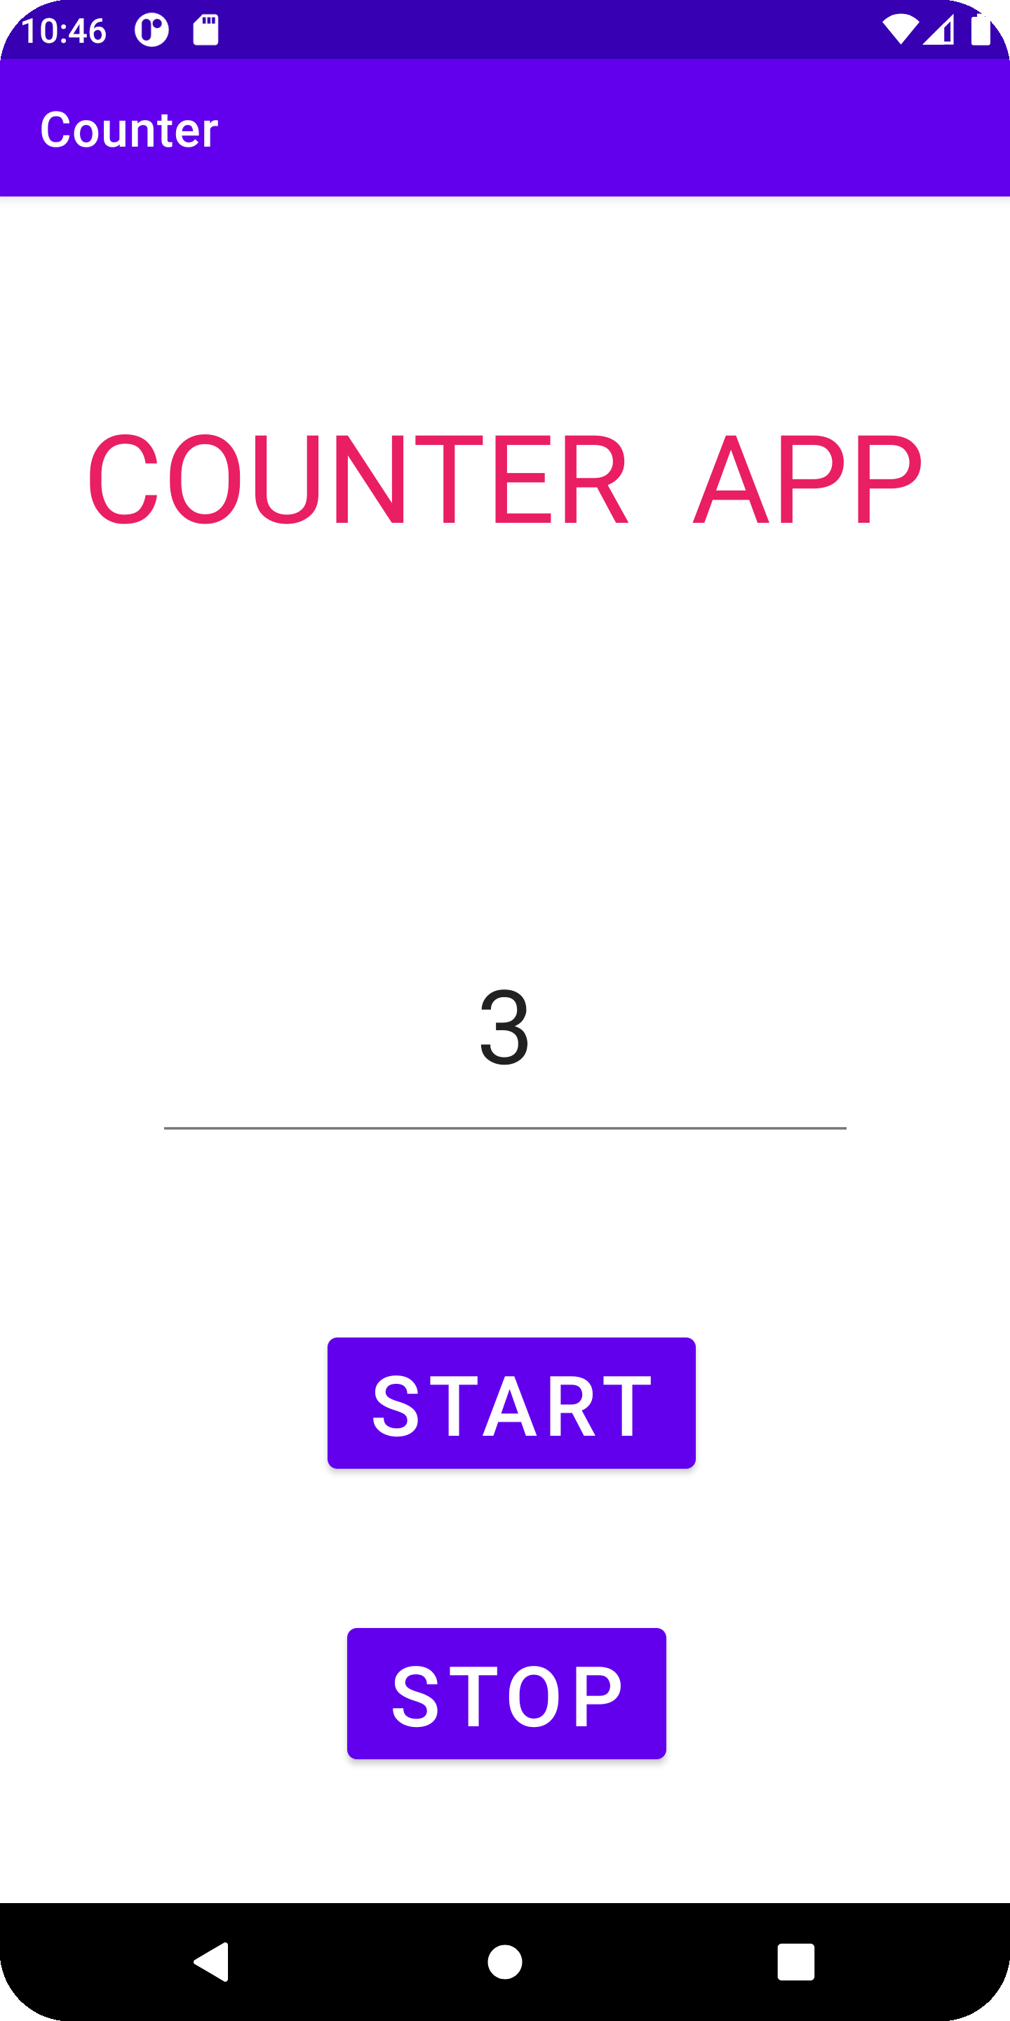

package com.example.counter;  
  
import androidx.appcompat.app.AppCompatActivity;  
import android.os.Bundle;  
import android.os.Handler;  
import android.os.Message;  
import android.view.View;  
import android.widget.Button;  
import android.widget.TextView;  
  
public class MainActivity extends AppCompatActivity implements View.OnClickListener{  
 TextView lblCounter;  
 Button btnStart,btnStop;  
  
 int counter=0; boolean running=false;  
  
 @Override  
 protected void onCreate(Bundle savedInstanceState) {  
 super.onCreate(savedInstanceState); setContentView(R.layout.*activity_main*);  
 lblCounter=(TextView)findViewById(R.id.*cv*);  
 btnStart=(Button)findViewById(R.id.*btn1*);  
 btnStop=(Button)findViewById(R.id.*btn2*);  
 btnStop.setOnClickListener(this);  
 btnStart.setOnClickListener(this);  
 }  
  
 public void onClick(View v)  
 {  
 if(v.equals(btnStart))  
 {  
 counter=0; running=true;  
 new MyCounter().start();  
 }  
 else if(v.equals(btnStop))  
 {  
 running=false;  
 }  
 }  
  
 Handler handler=new Handler()  
 {  
 public void handleMessage(Message m)  
 {  
 lblCounter.setText(String.*valueOf*(m.what));  
 }  
  
 };  
  
 class MyCounter extends Thread  
 {  
 public void run()  
 {  
 while(running)  
 {  
 counter++; handler.sendEmptyMessage(counter);  
  
 try { Thread.*sleep*(1000);  
 }  
 catch(Exception e) { }  
 }  
 }  
 }  
}